⚙️ During installation (follow exactly)

Note: uninstall all langflow ,python ,Visual studio code build tools before starting this step
To uninstall

Go to control panel-programs-Programs and Features –uninstall the above mentioned.
Download Python 3.10.x installer from python.org (Windows installer).
- Installer: choose Windows x86-64 executable installer for 64-bit.
Downloads-View full list of downloads

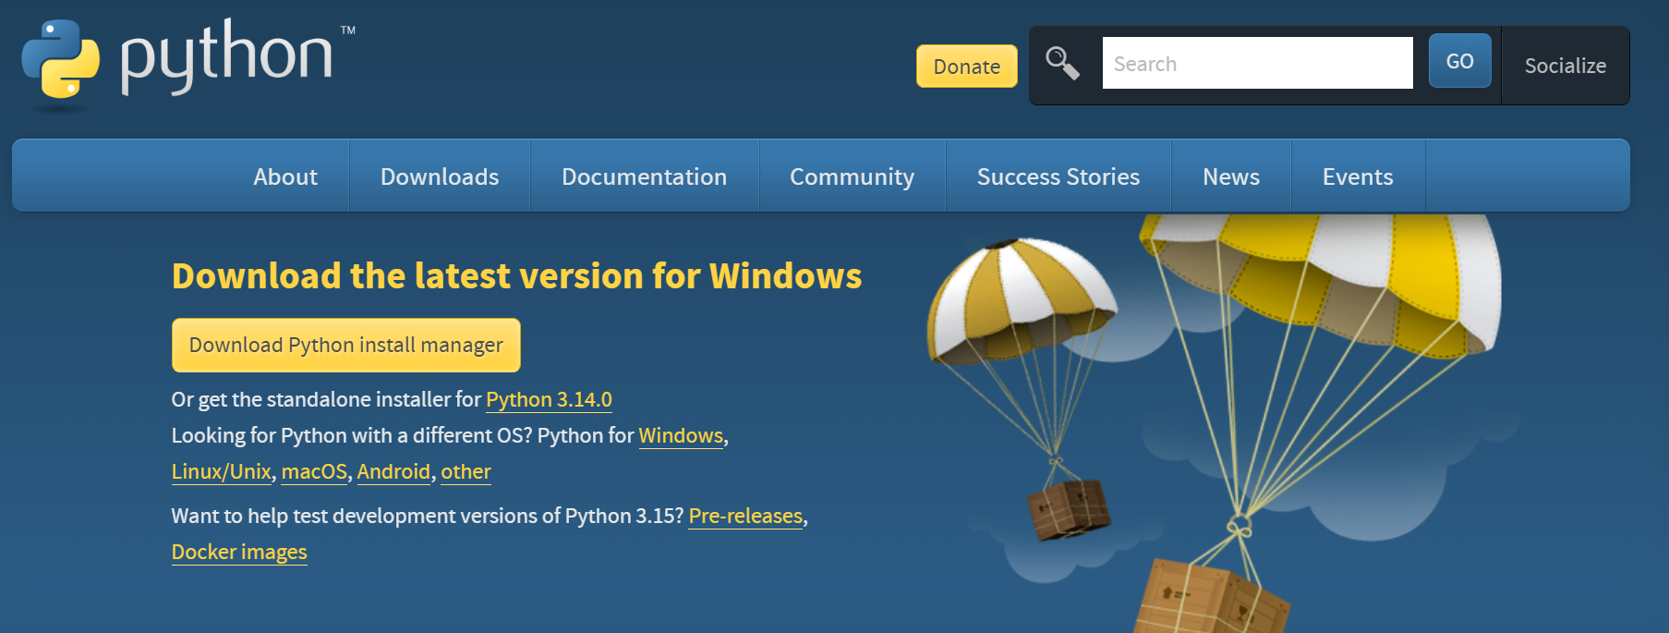

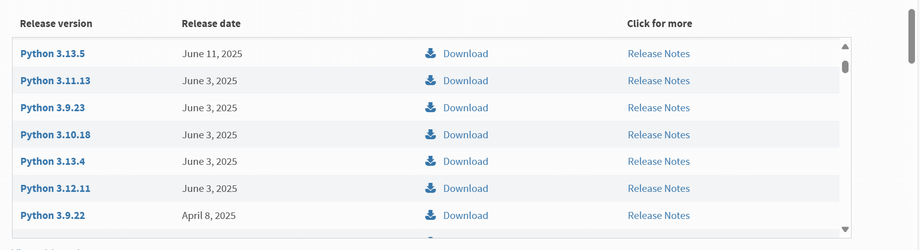
- ✅ Check “Add Python 3.10 to PATH.”
- Click Customize installation → Next.
- On the Advanced Options screen:
  - ✅ Check “Install for all users.”
  - ✅ Check “Add Python to environment variables.”
  - ✅ Change Install location to: C:\Python310
- Finish installation.
- Open a new Command Prompt and verify:

where python
python --version
python -m pip --version
You should see the screen like below
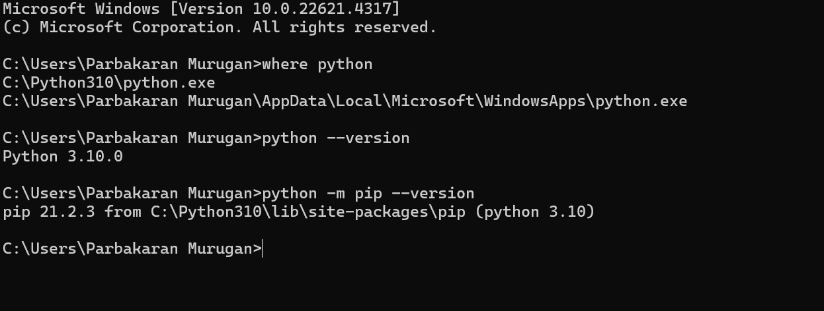

Once you see this above screen
Step 1 — Open Command Prompt as Administrator
Step 2 — Create a new, clean environment
Run this in cmd

rmdir /s /q C:\LangflowEnv
python -m venv C:\LangflowEnv –copies

Then activate it:

C:\LangflowEnv\Scripts\activate.bat

You should now see:
(LangflowEnv) C:\>
Step 3 — Upgrade pip and base tools
run this in cmd
python -m pip install --upgrade pip setuptools wheel
Confirm pip version ≥ 24.x:

python -m pip –version
Step 4 — Install Langflow

pip install langflow

Wait for installation to finish (it might take a few minutes).

Step 5 — Run Langflow

Run this in cmd

python -m langflow run

When it starts, you’ll see:

INFO: Uvicorn running on http://127.0.0.1:7860

Now open this in your browser manually:

http://127.0.0.1:7860

then you will see langflow page

